Dear Parents and Carers,
Welcome to Class 1! I am Miss Craig-Dennis and I am very pleased to have joined the staff at Woodborough Woods Foundation C of E School. I have been very excited to welcome all your lovely children into Class 1. The first few days have been great with lots of fun and learning. I am looking forward to watching your child grow and progress throughout the year.
On Tuesdays, I will be out the class and therefore the children will have Mrs Macintyre. The teaching assistants involved with Class 1 are Mrs Crofts and Mr Robinson.
General Information:
SNACKS AND WATER: Please ensure that your child brings water in their labelled drinking bottles and that they have a healthy snack for morning and/or afternoon. If they bring it in a snack pot, please ensure these are named. No crisps, chocolate or sweets please.
HOMEWORK: The children will receive one piece of homework each week and sometimes may have an extra bit of topic to do; they will have the 10 spellings to learn each week; they will be expected to read at least 3 times.
FOREST SCHOOL: On Friday afternoons, the children in Class 1 will be partaking in Forest School sessions with our outside providers - ‘Little Adventurers’. This sometimes can be a little bit muddy, especially in the autumn term. We kindly ask that your children bring a plastic bag with a pair of old trainers, a pair of old tracksuit bottoms and an old sweater. If the weather looks wet, we will still be going out so please don’t forget a waterproof jacket too. These sessions start this week.
We’ve got an exciting first half term ahead of us and we can’t wait to get started. Here are some of the things we will be learning about:
The Autumn Term Curriculum in Class 1
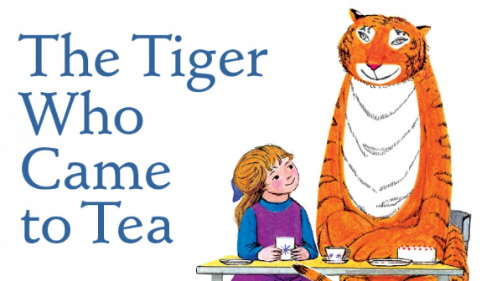
English
Our English work this half-term will be influenced by the topic animals. The book we will be focusing on is the ‘Tiger Who Came to Tea’ by Judith Kerr. Our writing tasks will be mainly based on composing a sentence orally before writing it. Also, re-reading what your child has written to check that it makes sense.
Each Thursday the children will be given a new list of ten spellings. They will then be tested on them the following Thursday. Please can you make sure your child practices their spellings beforehand. We will be sending out a list of the spellings each week by yammer.
The children should all come home with two reading books that is matched to their book band this week. It is expected that the children do at least 3 reads per week with an adult. Each child will also have the opportunity to go to the school library and choose a book to take home to read each week. Please sign in their diaries when you have read with them. If they read three times in a week, there will be rewards on offer. We will check the three reads on a Monday.
After you have read at home, remember to pop their reading diary and books back into their bag ready for the next day as the children have the opportunity to read to a member of staff at school. Each time you read with your child at home, please write the details on the right side of the double page spread. If staff are reading with them, this will be done on the left side. If a parent reader volunteer reads with your child in class, we'll ask them to write and sign on the right - the same side as you - so that it classes as a parent read (this will count towards the total number of reads).
Maths
The Maths learning follows the White Rose Maths scheme, which ties in with the New Primary Curriculum. Key mathematical concepts covered this term include: place value, addition and subtraction.
Geography
We are starting the term with learning about human and physical geography. This includes understanding and identifying seasonal and daily weather patterns in the United Kingdom and the location of hot and cold areas of the world in relation to the Equator and the North and South Poles.
Science
Our science this half term will be about animals including humans. We will be identifying and naming a variety of common animals including fish, amphibians, reptiles, birds and mammals. We will also be learning about which of these animals are carnivores, herbivores and omnivores, and comparing the structure of these animals. The final area in this topic, the children will be learning about the basic parts of the human body and will be able to associate these parts with each sense.
Art and Design and Technology
The children will be engaging in a number of creative activities linked to our class topic animals.
Computing
This half term we will be looking at online safety and exploring. We will be using the Purple Mash app for this.
PE
This half term PE sessions will be on a Thursday and Friday and will be delivered by our specialised PE coaches.
RE
This half term we will be finding answers to the big question ‘What do Christians believe God is like?’.
PSHE
The focus will be on the first of our whole school themes for the year, health and wellbeing; this includes learning about healthy lifestyles, growing and changing and keeping safe.
Finally, if require any further information or have any questions, please do not hesitate to message me on Yammer or alternatively email me at ecdennis@woodsfoundation.notts.sch.uk. I am always very happy to help. 😊
Kindest Regards,
Miss Craig-Dennis

