Woodborough Wood’s Foundation C of E (Aided) School
Class 1 Newsletter
Autumn Term 2 2022
Dear Parents and Carers,
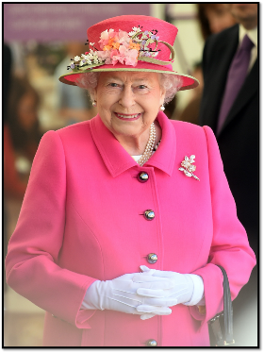
Welcome back after half-term. I hope that the children enjoyed spending time with their friends and family. I am very pleased with how the year is going so far and I hope the children are enjoying Class 1 as much as I am teaching them. Our new topic this half-term is Queen Elizabeth II. We will focus lots of our learning around Queen Elizabeth.

Please contact me privately for teacher parent meetings on the 28th and 29th of November. I will be offering 10-minute slots for each child.

Please, read the general information below as some points have changed since Autumn 1.

General Information:

Snacks and Water: Please ensure that your child brings water in their labelled drinking bottles and that they have a healthy snack for morning and/or afternoon. If they bring it in a snack pot, please ensure these are named. No crisps, chocolate or sweets please.

Homework: The children will receive a paper copy of the new homework grid to be completed over the duration of half-term. There are lots of different homework activities which are related to our learning this half-term. The children can choose their homework tasks from the grid and complete it over the next few weeks. I will be asking them to bring their completed work into school on Monday 12th December. The children will have the opportunity to showcase their work to the rest of the class on the following week (w/c 19th December). The children can choose 2 other activities they complete over the course of the half-term. As usual spellings, reading and phonics sound practise is expected each week.

Forest School: There will be no Forest School this half-term.

We’ve got an exciting half-term ahead of us! Here are some of the things we will be learning about:
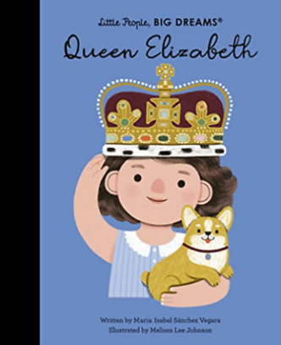
Autumn 2 in Class 1

English: Our English work this half-term will be influenced by the topic Queen Elizabeth. The class text we will be focusing on is ‘Queen Elizabeth’ Little People, Big Dreams by Maria Isabel Sánchez Vegara. We will also be looking at properties of writing a letter. Our writing tasks will be based on using a capital letter for names of people, places, the days of the week and the personal pronoun ‘I’. The children will also learn what an exclamation mark is and how to use it correctly within their writing.

The children will be tested on their spellings every Thursday. Please can you make sure your child practices their spellings beforehand. I have sent out a hard copy of the spellings for the entire half-term and I will send regular reminders on Yammer.

Every Monday, the children should all come home with two reading books that is matched to their book band. It is expected that the children do at least 3 reads per week with an adult. Each child will also have the opportunity to go to the school library and choose books to read for pleasure over the half-term. In KS1, please use the reading records continuously and sign in your child’s diary when you have read with them. I have kept a record of how many reads your child has achieved over the course of Autumn 1. There have been some fantastic results! After you have read at home, remember to pop their reading diary and books back into their bag ready for the next day as the children have the opportunity to read to a member of staff at school.

Maths: The Maths learning follows the White Rose Maths scheme, which ties in with the New Primary Curriculum. Key mathematical concepts covered this term include Addition and Subtraction.

History: History is the driver subject for this half-term. The National Curriculum objective we are looking at is ‘changes within living memory’. We will be looking at Queen Elizabeth’s reign and the changes within national life since her coronation.

Science: We will continue with the ‘animals including humans’ objectives on the National Curriculum. The final area in this topic, the children will be learning about the basic parts of the human body and will be able to associate these parts with each sense.

Design and Technology: The children will be designing, creating and evaluating corgi puppets this half-term.

Computing: This half-term we will be looking at pictograms and lego builders. We will be using the Purple Mash app for this.

PE: This half-term PE sessions will be on a Thursday and Friday and will be delivered by our specialised PE coaches.

RE: The topic this half-term in RE is ‘incarnation’; this involves understanding why Christmas is an important time for Christians.

PSHE: Within PSHE, we will be continuing with health and wellbeing; this includes learning about healthy lifestyles, growing and changing and keeping safe.

Finally, if require any further information or have any questions, please do not hesitate to message me on Yammer or alternatively email me at ecdennis@woodsfoundation.notts.sch.uk. I am always very happy to help. 😊

Kindest Regards,
Miss Craig-Dennis

