Dear Parents and Carers,
Hello! I hope your children enjoyed their first week of Autumn Term 2. Last week the class and I had an exciting week, joining in with the Harvest Festival led by Year 3, and also having a special visit from a paramedic and look around an ambulance!
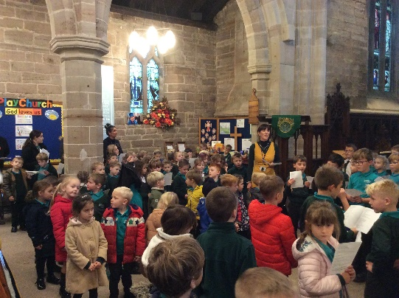

Harvest Festival at St Swithun’s Church.
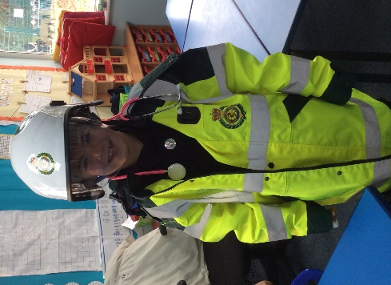
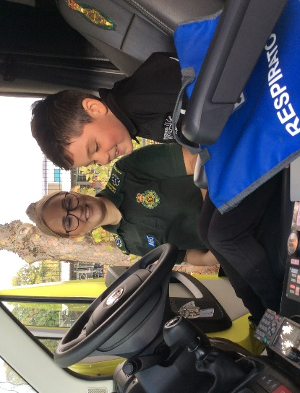
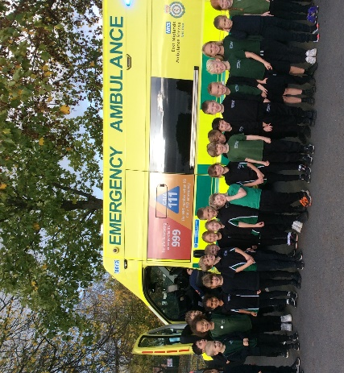
KS1 Ambulance visit.

This term our topic will be all about the Victorians. As part of this we will be going on a class trip to Newstead Abbey to join ‘The Webb family’s Victorian Christmas’! We will also spend time preparing for the Key Stage 1 nativity ‘Lights, Camel, Action!’ which will be really fun. Parents evening is also this term, on the 28th and 29th of November. If you haven’t already, please send me a message on yammer to arrange an appointment.

A quick reminder to make sure that your child brings water in their labelled drinking bottles, and that they have a healthy snack for morning and/or afternoon break. Please be aware that children’s snacks should not be crisps, chocolate or sweets. Some students have been bringing these in for breaktime snack, however have not been able to eat these, due to school policy.

The Autumn Term 2 Curriculum in Class 2:
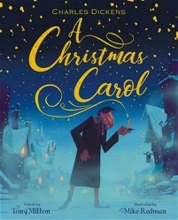
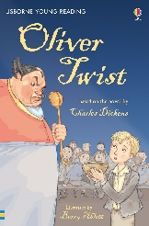
We have lots of fun, different activities for the children to complete across the whole curriculum. Here is a little bit of information about what we will be covering in each subject.
- English: We will be looking at two classic Victorian books in Autumn Term 2 – Oliver Twist, and A Christmas Carol.
- Maths: In Maths, the school follows the WhiteRose Maths scheme. The areas we will cover this term will be addition and subtraction, and shape.
- History: We will be learning all about Queen Victoria, and what life was like for people who lived in the Victorians.
- Art: The children will be learning about Victorian artist William Morris, and creating their own versions of his work.
- RE: This half term we will be finding answers to the big question ‘Why does Christmas matter to Christians?’.
- PE: The children will have PE every Thursday morning and Friday afternoon, which will be delivered by our specialist PE coaches. Please make sure that your children wear their PE kits to school those days, and those with long hair have it tied up.
- Computing: During this half term, the children will be completing ICT on a Tuesday with Miss Hallam. They will be learning about coding.
- PSHE: We will continue to focus on Health and Wellbeing; this includes learning about Healthy Lifestyles, Growing and Changing and Keeping Safe.

Finally, if you require any further information or have any questions please feel free to contact me, either via Yammer or email. My email address is hbray@woodsfoundation.notts.sch.uk.

Kindest regards,
Miss Bray

