Dear Parents and Carers,
Hello and welcome to Class 2! My name is Miss Bray and I am very excited to be part of the Woodborough Woods team, and be the Class 2 teacher. The class and I have had a great first week together, and we even had a Space Day where they learnt about celestial bodies, Neil Armstrong, and created some lovely galaxy themed art work! I am really looking forward to helping your child grow and progress over the next year.
In year 2, we are lucky enough to have the support of Miss Attenborough on Mondays, Tuesdays and Wednesdays. On Tuesdays, I will be out of the classroom and therefore the children will have the opportunity to work with the lovely, Miss Hallam.

General Information:
- Snacks and water – Please make sure that your child brings water in their labelled drinking bottles, and that they have a healthy snack for morning and/or afternoon break. If their snack is in a tupperware container, please make sure this is labelled too. Please be aware that children’s snacks should not be crisps, chocolate or sweets.
- Homework – Each week the children will be asked to learn 10 spellings for the following week, which will be sent out on Yammer. The spellings will be linked to the class’ phonics lessons from the previous week, so that the children become familiar with the sound that the letters are making. There will also be a few high frequency words included too.
The children are also expected to read at home. Your child will bring home 3 books to read – a book of their choice, a monster phonics book, and a rising stars book. Each time you read with your child at home, please write the date, the name of the book, write a comment, and sign it. Please write continuously throughout the reading record, using both sides of the record. It is expected that the children read at least 3 times a week which will help them earn their reading reward, details of which will follow soon.
It has also been brought to my attention that the current Reading Records include Year 1 Phonics, Common Exception Words, and High Frequency Words. We are in the process of buying Year 2 level Reading Records, and I will update you once these have arrived.
- Forest School – Commencing the 16th September, the children will have Forest School every Friday for the first half of the Autumn term. Please make sure that your child brings an old T-Shirt or hoodie to school, trainers, and waterproofs incase of wet weather.

The Autumn Term 1 Curriculum in Class 2:
For the first half of the Autumn term, Class 2’s topic will be Animals! We have lots of fun, different activities for the children to complete across the whole curriculum. Here is a little bit of information about what we will be covering in each subject.
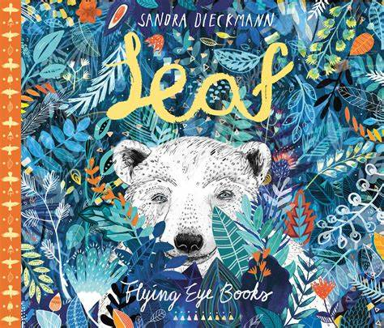
- English: We will be looking at two books in Autumn Term 1 – ‘Leaf’ by Sandra Dieckmann, and ‘The Owl who was Afraid of the Dark’ by Jill Tomlinson. We will look at ‘Leaf’ first, and focus on retelling the story, and then rewriting their own version of the story.
- Maths: In Maths, the school follows the WhiteRose Maths scheme. The areas we will cover this term will be place value, addition and subtraction.
- Science: Our science this half term will be about animals including humans. We will be identifying the basic needs of animals and humans, and see what is needed for humans to have a healthy lifestyle.
- Geography: We are starting the term with learning about human and physical geography. This includes understanding and identifying seasonal and daily weather patterns in the United Kingdom and the location of hot and cold areas of the world in relation to the Equator and the North and South Poles.
- Art: The children will be engaging in a number of creative activities linked to our class topic animals.
- PE: The children will have PE every Thursday and Friday, which will be delivered by our specialist PE coaches. Please make sure that your children wear their PE kits to school those days, and those with long hair have it tied up.
- Computing: During this half term, the children will be completing ICT on a Tuesday with Miss Hallam. They will be learning about coding.
- RE: This half term we will be finding answers to the big question ‘What do Christians believe God is like?’.
- PSHE: The focus will be on the first of our whole school themes for the year, Health and Wellbeing; this includes learning about Healthy Lifestyles, Growing and Changing and Keeping Safe.

Finally, if you require any further information or have any questions please feel free to contact me, either via Yammer or email. My email address is hbray@woodsfoundation.notts.sch.uk.

Kindest regards,
Miss Bray

