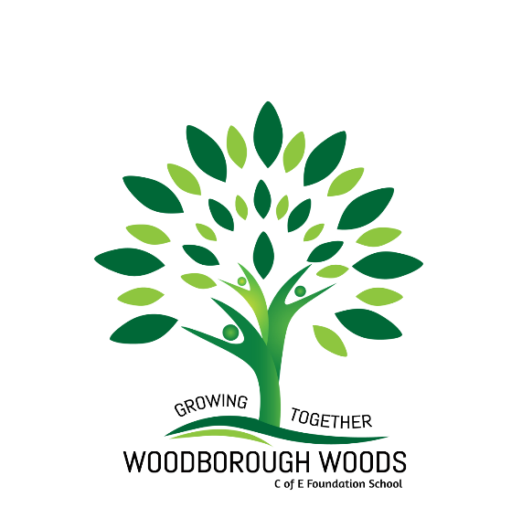

**Art Leadership**

Our Art Curriculum coordinator, Miss Craig-Dennis, is responsible for developing an enriched art curriculum and delivering training on developments of planning, schemes of work and teaching across the school.

**Curriculum Design**

The curriculum is designed to be a fun and rewarding way for people to express themselves and to learn a broad range of skills and concepts. In making art, students explore the materials and techniques used by artists and architects, and experience the

decision-making practices that artists have used over the centuries.

**Wider School Curriculum**

Children at Woodborough Woods have the opportunity to work closely with professional artists from the local village ‘Woodborough Art Group’ every half-term. The workshops focus on building upon the children’s skills and give each pupil the opportunity to produce a piece of artwork based on the schools’ values. The local art group have regular exhibitions to display the children’s art.

**Art Skills**

Each year group will partake in age-appropriate learning in the following units: drawing, painting, sculpture, printing, and textiles.

**Curriculum Intent**

Through our provision we aim that children:

* use a range of materials creatively to design and make products.
* use drawing, painting, and sculpture to develop and share their ideas, experiences, and imagination.
* develop a wide range of art and design techniques in using colour, pattern, texture, line, shape, form, and space.
* understand the work of a range of artists, craft makers, designers and architects describing the differences and similarities between different practices and disciplines and making links to their own work.
* record their observations and use them to review and revisit ideas.

**Our Vision**

Art and design is an essential part of the primary curriculum. At Woodborough Woods children explore and develop their skills and creativity using a wide range of media. We value the use of sketch books and encourage the importance of experimentation, exploration and pushing ideas in imaginative ways. Art allows the child to develop their imagination and creativity, to make connections through their inventive minds and gives children the skills to record their imagination and ideas. While it is essentially a practical subject, art should provide opportunities for reflection and pupils should acquire the ability to make informed, critical responses of their own work and that of others. At Woodborough Woods, we aim to provide an art curriculum whereby children can grow to discover and develop their own individual talents.