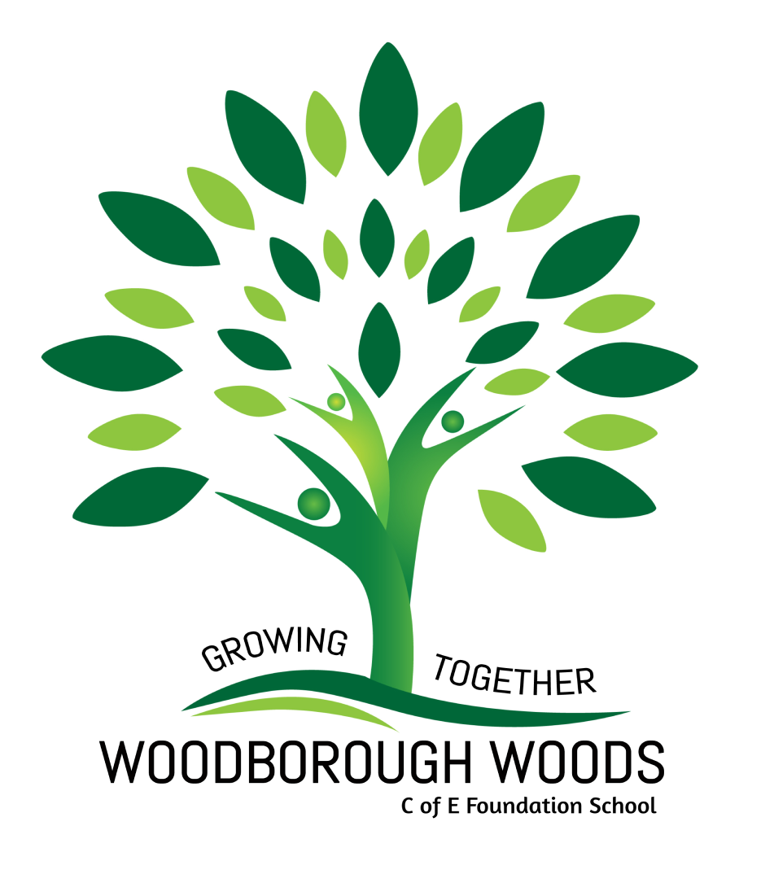

Art Policy 2023

Our Vision:
At Woodborough Woods, it is our firm belief that our art curriculum should engage, inspire and challenge in order to enhance and enrich all children’s learning and improve outcomes for learners of all ages. Through the development of many different skills, we attempt to acquire both knowledge of artists’ work and a desire to experiment, invent and create our own works of art, craft and design. This will be made possible by having a consistent and inspiring approach to a curriculum that provides a wide range of experiences.
Aims:
- To develop creativity and imagination through a range of first-hand activities and experiences.
- To become proficient in drawing, painting, sculpture and other art, craft and design techniques.
- To provide children with visual, tactile and sensory experiences to develop and enhance their experiences of the world.
- To develop children’s ability to value and appreciate the contribution made by other artists, craftspeople and designers and respond critically and imaginatively to ideas, images and objects from different times and cultures.
- To enable children to record from first hand opportunities and from imagination.
- To communicate their ideas and feelings through a range of materials, tools and techniques.
- To develop increasing confidence to self-evaluate and analyse their work using the language of art and design in order to develop future work and outcomes.
- To know about great artists, craft makers, architects and designers and understand the historical and cultural development of their art forms.

Teaching and Learning:
Children will be given the opportunity to develop key concepts, skills and attitudes in art throughout the key stages by encouraging them to explore a variety of different media, develop their fine motor control, their observational skills and their appreciation of the use of colour, pattern, texture, line, shape, space and form. The work of artists, craft makers, architects and designers, from other cultures and times enables the children to look with interest and understanding at a variety of creative expressions.
In each year group the children are encouraged to improve their mastery of art and design techniques including drawing, painting and sculpture with a range of materials.
Curriculum Planning and Provision:
In order to achieve our aims, our art curriculum is organised into a combination of topics across the key stages, linked where appropriate to other subjects, to provide meaningful and purposeful opportunities to develop children’s skills through a cross-curricular approach.
Children are taught through a combination of direct teaching, real experiences, use of teacher prepared materials, other artists, craft makers, architects and designers work, visits from local art group and media.
Assessment, Recording and Reporting:
The children’s work is assessed, and verbal feedback is given whilst observing and working with them during lessons by class teacher and members. Teachers may also keep evidence of the children’s work often as a photographic record which shows children’s achievements. Progression and achievement are shown in the teacher’s medium-term plans and within the school’s progression document.
Sketchbooks:
Each child keeps a sketch book, which moves up with them through the school, to record their observations, develop their technical drawing, explore new tools and techniques and review and revisit ideas.
Monitoring and Review:
The art subject lead will oversee the continuity and progression across the school. They will monitor and gather evidence to show the quality of teaching and the expected standards of children’s work.
The art leader will support colleagues and share expertise, arrange opportunities for outside agencies to visit the school and enhance learning, advise teachers on the objectives and teaching methods for the next year and encourage staff and pupils’ creativity.
SEND:
Our art curriculum is accessible to all the children in school regardless of their capabilities. Art activities should be planned so that all children with special needs may have the opportunity to participate fully. Children with particular emotional needs, or communication difficulties will benefit enormously from being able to express themselves in an artistic way. The values of these opportunities should be exploited to their full potential.
Resources:
We have a wide range of resources which are used to aid the teaching of art. Class teachers are responsible for ensuring they have the materials they require to support the objectives and activities they have planned. The Art Leader is responsible for coordinating the purchasing and maintenance of equipment and materials and asks the class teachers to complete a resource and supplies order form every term. Advice and support are given by the Art Leader to the class teachers if required.
Health and Safety:
Health and Safety issues in art include the storage and use of materials, and the use of tools and techniques in accordance with the Health and Safety requirements.
Children are instructed in the correct and appropriate use of all resources and are supervised during all activities. They are made aware of specific dangers and are shown the appropriate and safe way to use the equipment and materials.
Equal Opportunities:
All children should be entitled to develop their artistic potential as far as possible. The school art scheme has been planned to ensure that the critical studies component will expose pupils to a balance of artists from both genders and from a range of cultures both European and non-European.
Cross Curricular Links:
We believe that art is a subject which supports and enhances learning in other areas and therefore, cross-curricular links are exploited where appropriate. Art is also taught as a subject in its own right when appropriate. We also provide after school activities to give the children additional opportunities to experiment with a variety of tools and techniques.
Subject Leaders Role:
The art subject leader will:
- Seek to enthuse pupils and staff about art and promote high achievement.
- Advise and support staff in the planning, delivery, and assessment of art.
- Manage and develop all resources for art.
- Monitor and evaluate art throughout the school.
- Keep up to date with current developments through attending courses and feedback this information to staff through inset and staff training.
- Assist in the delivery of the Art Curriculum.

